Guide
URL: https://617522-sb2.app.netsuite.com/c.617522_sb2/pos/main.ssp?whence=&n=2#login
User: ilan@beauty.com
Password: Netsuite123!
Add item 9192

Location Based Pricing Script
Convert Script from 1.0 to 2.X

Explanation.
SCIS hardcodes the base price:
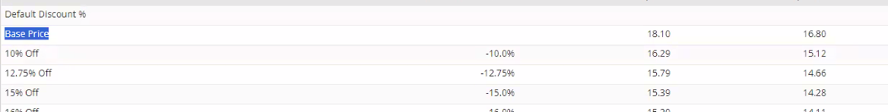
This customer wants to go to the location record:
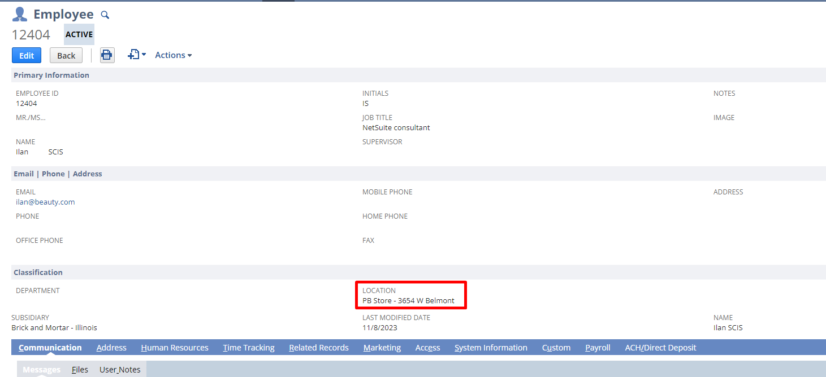
https://617522-sb2.app.netsuite.com/app/common/otherlists/locationtype.nl?id=5
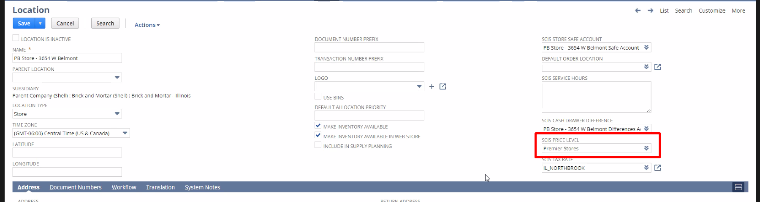
And they want to modify this SCIS Price level.
Looks on the location set on the employee -> looks on this field depending on the location set on the employe -> and then modify the value so

So, on SCIS add 9192 see base price is 18.00 and then when added, it says:
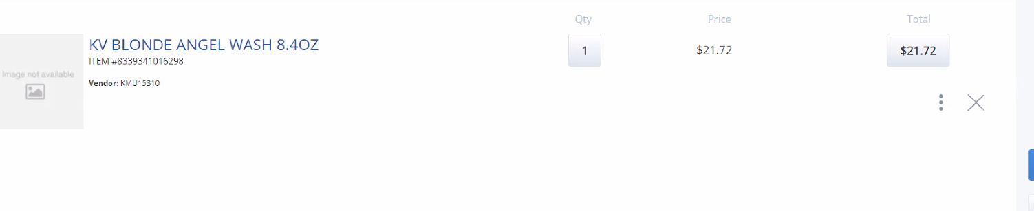
21.72
, and set a specific price level

Testing
Search for item 9192 -> add to cart, check if it works. If it does not, use Netsuite: Transactions -> sales -> Enter credit card sales:
- Customer: set default (Jeremiah)
- Location: Belmont
Then below, add item 9192 and error will appear.

Clean cache
Add ckinvalidate=T to url.
Clean cache by content management.

Customization for invoice and cash sales.

We will need to create a Client script that will deploy to invoice and cash sales.
To enable the client script running on SCIS:
Go to Commerce -> InStore -> Settings: select SCIS Settings -> mark checkbox execute client scripts.
Inside the client script:
Look at the customer, and if the field is on or off, make a tax exempt, so set tax code to non-taxable.

There is this transaction body field
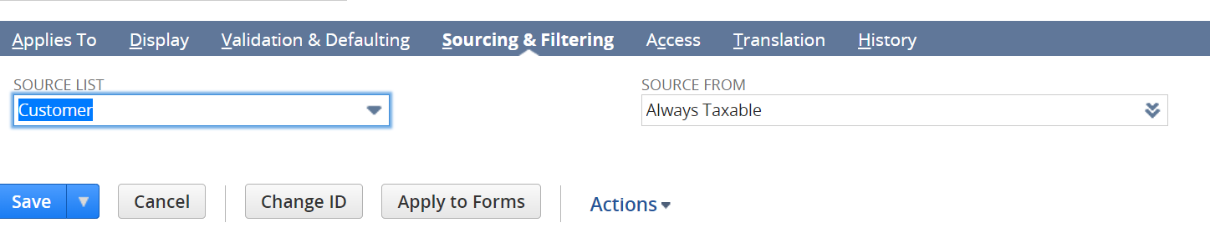
So, if customer has this field marked as false, it does nothing.
It is marked as true: -> set tax rate ONLY on items marked as non taxable.
So you have to set up this field on the table on “credit card sale” or “invoice”.
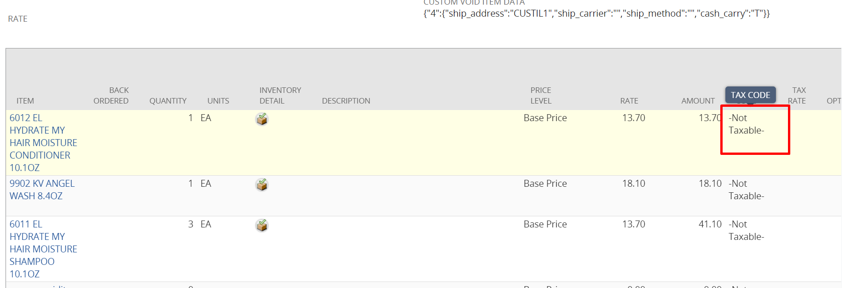

You obtain this tax rate from the location (it is going to be added as a new field, like we did with the script convert below)

* Do it same way as we are going to do it with price level on Script. Repeat steps:
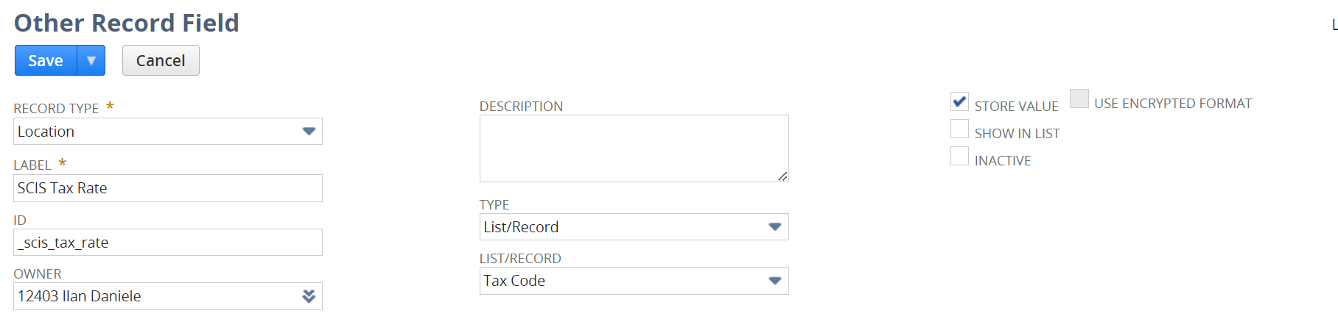
Then to fill up the value, use always:
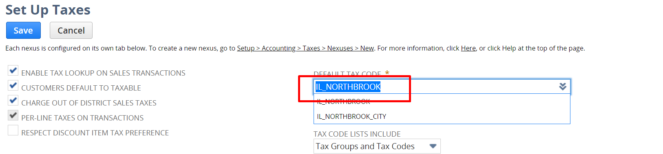

3 cases:
- Customer if it’s taxable -> native functionality
- If C it’s always taxable and item is added as non taxable -> we still add the tax (I do not know which tax, perhaps a parameter on the script, ask the customer)
- If the store were the employee is logged in
  - Get the store where the customer (employee currently logged) is logged in via a previous script
  - Then on customer record (customer that is added to the transaction, not employee currently logged in) there is a free form text that will have all the subsidiaries that will apply the tax or not to the customer
  - Get these subsidiaries and compare with the id from the employee currently logged in

We have to create a custom body field that sources from the customer record.
(40hs)

3.
Add a new field to location: pricelevel
Setup -> Company -> Location: open the Belmont one
Press top right customize -> new field:
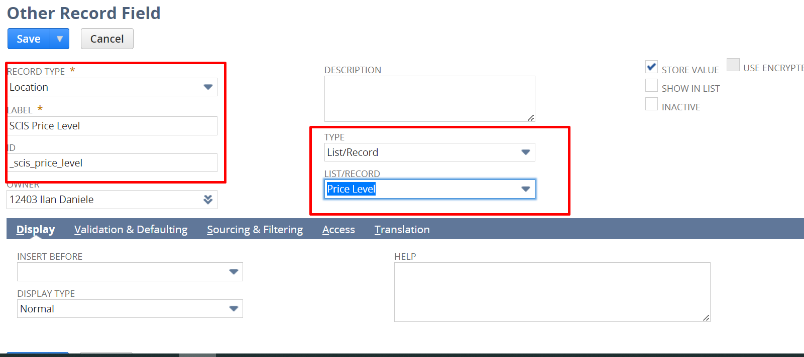

Then go back to location and now you can see field is added, populate that:
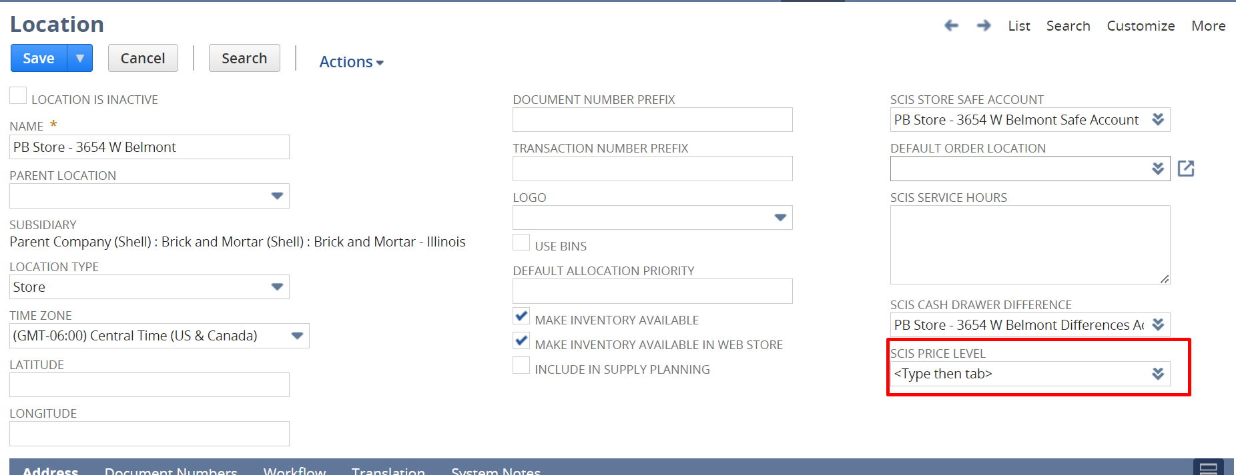
Set Premier Stores

Go to your employee record and set this location:
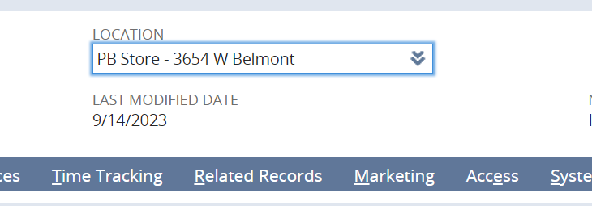
My script is gonna look at the location were my employee record is set, and then it’s going to look at the pricelevel inside.

Add transaction line fields:
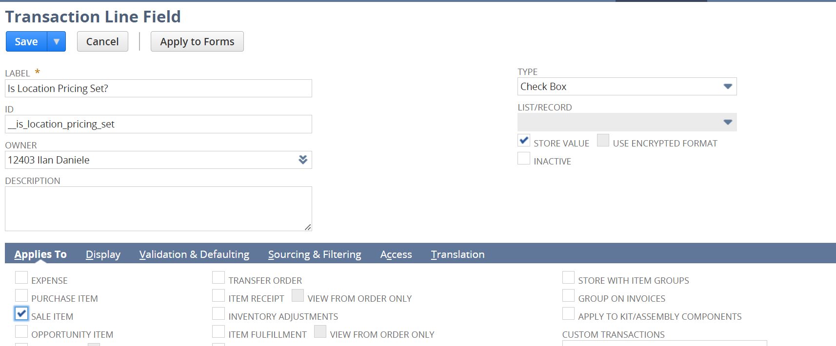
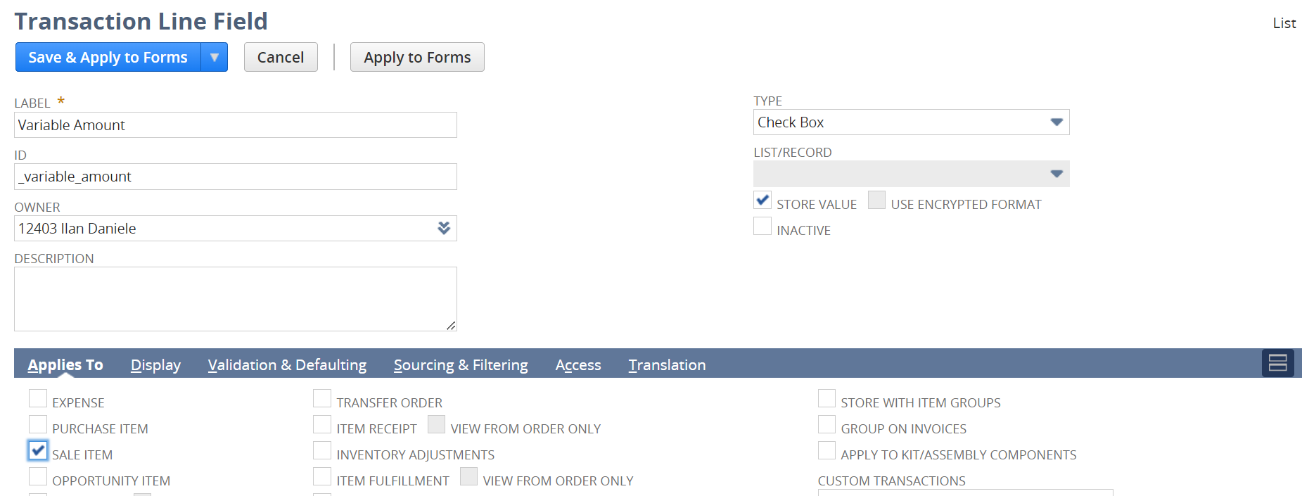
Select also this for both transaction line fields:
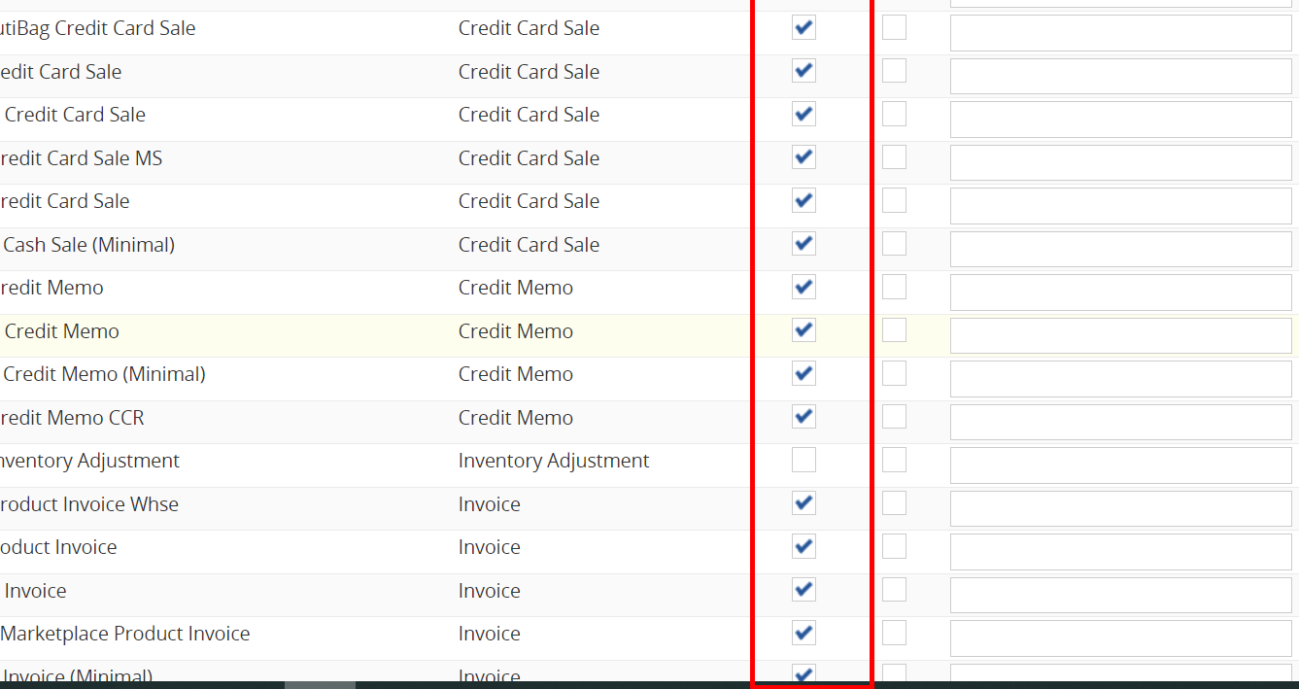

Deploy the script for Invoice and Credit Card Sale.

Next step:
Extend the script so, if customer is SCIS Customer always taxable: nlapiGetFieldValue('custbody_scis_cust_taxable')
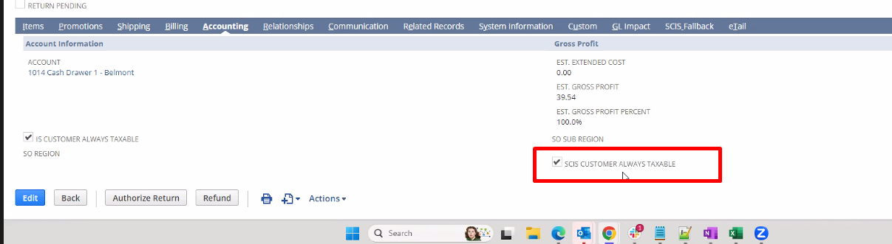
And any line item has SCIS override tax rate marked:
nlapiGetCurrentLineItemValue('item', 'custcol_scis_taxoverride');
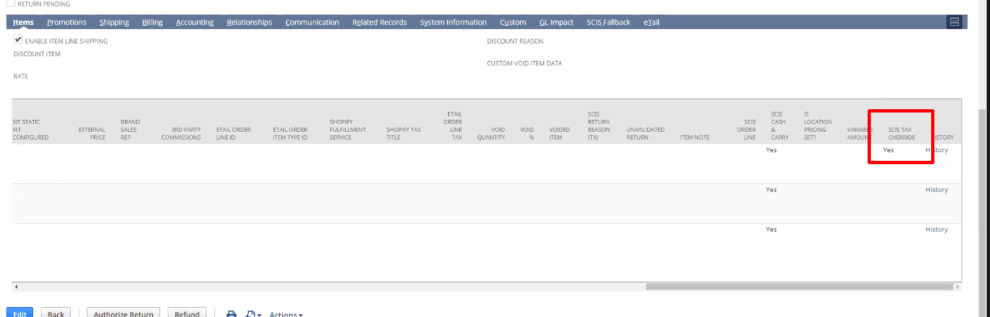
If this is the case, then we need to set tax code and tax rate. We get them by going to employee record -> get its location and:
Go to employee record -> get the location, then Setup -> Company -> Locations go to location and get SCIS Tax Rate from location:
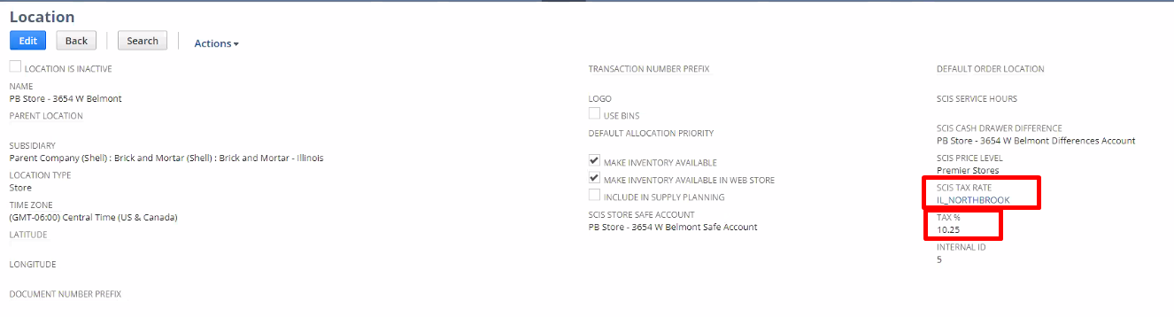
Custrecord_scis_tax

Then set:
nlapiSetCurrentLineItemValue('item', 'taxcode', "-7248", false, true);
nlapiSetCurrentLineItemValue('item', 'taxrate1', '10.25%', false, true);

Then apply code on tax override.js file
Some changes
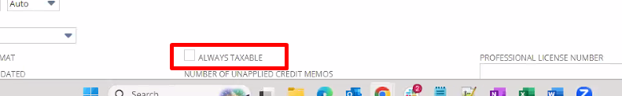
We are not using the always taxable anymore
scis_cust_taxable_in
scis_cust_taxable_il

Customer wants to be taxable in Indiana and Illinois, or not in one and yes in the other and viceversa: Customer record.
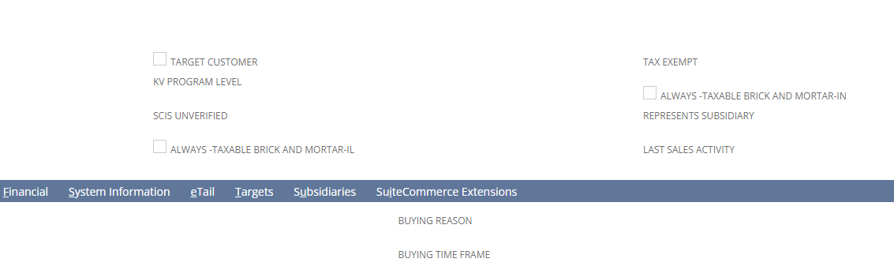
Get from the location if the location is in Indiana, or Illinois:
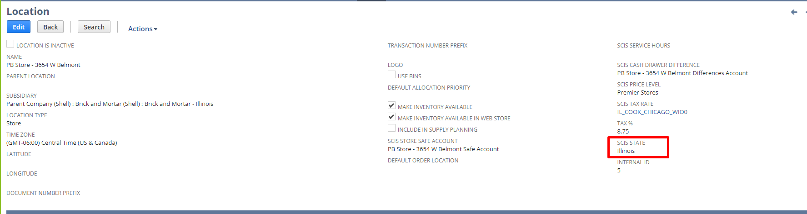

If always taxable IL is checked, and also the state from the location is IL, then do the tax rate

